Lab # 4
JAVA Conditional STATEMENT

OBJECTive

To Study Java conditional Statements.

THEORY

JAVA Control Statements

- The if-else Statement

The Java if-else statement works much like the IF statement in any other language. Here, condition is a Boolean expression. If condition is true, then the statement is executed. If condition is false, then the statement is bypassed.

- Simple if Statement:

Flow Chart

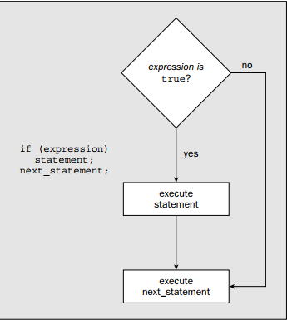

Syntax:

if(expression)
{ statement;
//body
}

Prorgam # 1

if(number%2 != 0) { // Test if number is odd
// If so make it even and output a message
++number;
System.out.println(“Number was forced to be even and is now “ + number);
}

- if Statement with else clause:
Flow Chart

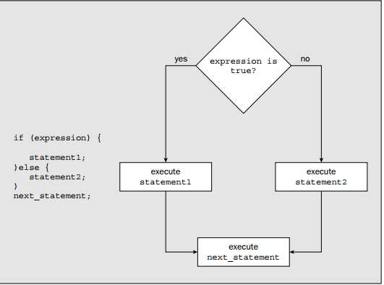

Syntax:
if (expression)
{ statement1;
}
else{
statement2;
}
next_statement;

Prorgam # 2

public class NumberCheck {
public static void main(String[] args)
{ int number = 0;
number = 1+(int)(100*Math.random()); // Get a random integer between 1 & 100 if(number%2 == 0)
{ // Test if it is even
System.out.println(“You have got an even number, “ + number); // It is even }
else {
System.out.println(“You have got an odd number, “ + number); // It is odd
}
}
}

- if-else-if Statement:
Flow Chart

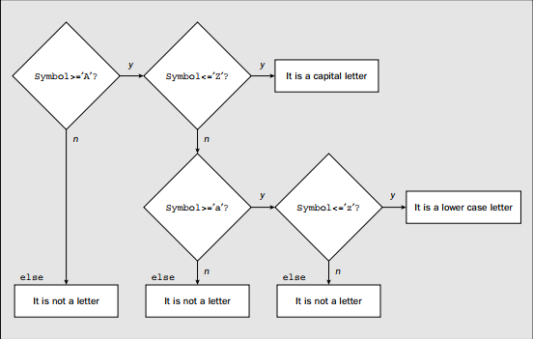

Syntax:
if (expression)
{ statement1;
}
else if{
statement2;
}
else{
statement3;
}

next_statement;

Prorgam # 3

class IfElseDemo {
public static void main(String[] args) {

int testscore = 76;
char grade;

if (testscore >= 90) {
grade = 'A';
} else if (testscore >= 80) {
grade = 'B';
} else if (testscore >= 70) {
grade = 'C';
} else if (testscore >= 60) {
grade = 'D';
} else {
grade = 'F';
}
System.out.println("Grade = " + grade);
}
}

- Switch Statement

The switch statement is Java’s multiway branch statement. It provides an easy way to
dispatch execution to different parts of your code based on the value of an expression.
As such, it often provides a better alternative than a large series of if-else-if statements.

Flow Chart
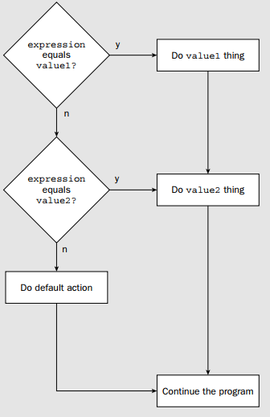
Syntax:
switch(caseOption) {
case 1:
Statament;
break;
case 2
Statament;
break;
default:
Statament;
break;
}

Prorgam # 4

switch(wash) {
case 1: // wash is 1 for Cotton
System.out.println(“Cotton selected”);
break;
case 2: // wash is 2 for Linen
System.out.println(“Linen selected”);
break;
case 3: // wash is 3 for Wool
System.out.println(“Wool selected”);
break;
default: // Not a valid value for wash
System.out.println(“Selection error”);
break;
}

- The for Loop
Flow Chart

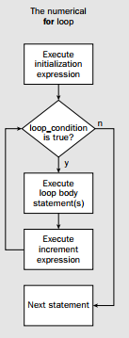

Syntax:

for(initialization; condition; iteration) {
// body
}

Prorgam # 5
public static void main(String[] args)
{ byte value = 1;
for (int i=0; i<8;i++)
{
Value*=2;
System.out.println(“Value is now:”+value);
}
}

LAB TASK

- Write a program to generate Fibonacci hypothesis for 19 generations given m below.

0 1 1 2 3 5 8 13 21 34 55 89 144 233 377 610 987 1597 2584 4181 6765

- Write a menu driven program that take integer input and option from user and check whether number is even, odd or prime using Switch statement.

Write a Java program that determines a student’s grade.
The program will read three types of scores(quiz, mid-term, and final scores) and determine the grade based on the following rules:
-if the average score >=90% =>grade=A
-if the average score >= 70% and <90% => grade=B
-if the average score>=50% and <70% =>grade=C
-if the average score<50% =>grade=F

- Write a Java program to calculate the revenue from a sale based on the unit price and quantity of a product input by the user.
The discount rate is 10% for the quantity purchased between 100 and 120 units, and 15% for the quantity purchased greater than 120 units. If the quantity purchased is less than 100 units, the discount rate is 0%.

- Write a Java program to get a number from the user and print whether it is positive or negative.

- Write a Java program to solve quadratic equations (use if, else if and else).

- Take three numbers from the user and print the greatest number.

- Write a Java program that accepts two floating point numbers and checks whether they are the same up to two decimal places.

- Write a Java program that reads a floating-point number. If the number is zero it prints "zero", otherwise, print "positive" or "negative". Add "small" if the absolute value of the number is less than 1, or "large" if it exceeds 1,000,000.

- Write a Java program that reads an positive integer and count the number of digits (less than ten billion) by using for loop.

- Write a program that accepts three numbers from the user and prints "increasing" if the numbers are in increasing order, "decreasing" if the numbers are in decreasing order, and "Neither increasing or decreasing order"

